FRUITS AND ITS COLOR USING BACKTRACKING

AIM: To implement a prolog program Fruits and its Color using backtracking.

OBJECTIVES:
- To implement backtracking in Prolog by storing different fruits and their colors and retrieving possible answers one by one.

ALGORITHM:
- Define facts representing fruits and their colors.
- Create a predicate fruit_color/2.
- Query a fruit or color.
- Prolog searches the facts sequentially.
- Press ; after an answer to activate backtracking and obtain the next solution.

SYSTEM-ARCHITECTURE:
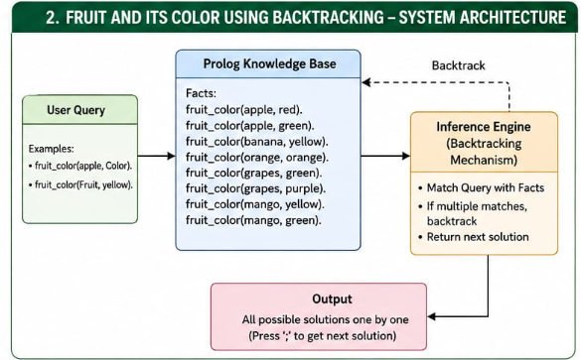

PROGRAM:
% Fruit and Color using Backtracking

fruit_color(apple, red).
fruit_color(apple, green).
fruit_color(banana, yellow).
fruit_color(orange, orange).
fruit_color(grapes, green).
fruit_color(grapes, purple).
fruit_color(mango, yellow).
fruit_color(mango, green).

OUTPUT:
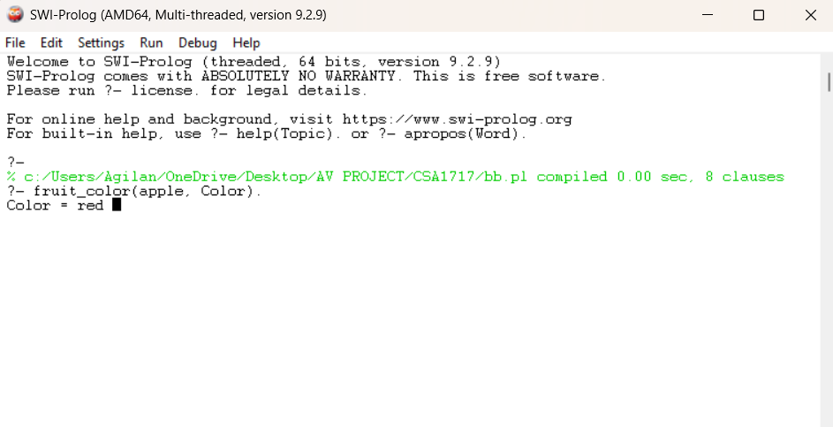

RESULT: Thus the Fruit and its Color using Backtracking is implemented successfully using Prolog program.

